Oceania International Figure Skating Competition 2024
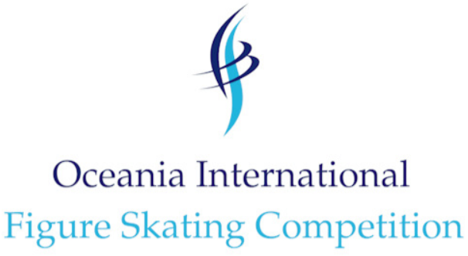
May 29 – 31, 2024 / Melbourne, Victoria – AUS

Visa Request Form

THIS FORM MUST BE RETURNED AS SOON AS POSSIBLE!
Visa processing can take several weeks or months in some countries.
Please complete this form as soon as possible to allow enough time for processing the visa request!
Please fill in the blanks below per the passport for all individuals who require a visa. Please attach a copy of each passport.
Family (Last) Name | Given (First) Name | Address | Passport Number | Validity of passport (DD/MM/YYYY | Sex (male/female) | Function in Team | EMBASSY where VISA will be processed

ISU Member Federation: ________________________________________ Date: _______________ Signature: ___________________________________

